**Final Project Report**

# **Introduction**

Leukemias represent a broad range of neoplastic diseases that affect different parts of the blood and lymph systems. Essentially, they can be called “blood cancers”, which impacts a person’s immune system. In the United States and Europe, the incidence is reported to be 3 to 5 cases per 100,000 with rates that increase in proportion with age. Among the acute leukemias, acute myeloid or myelogenous leukemia (AML) is the most common – up to 80% of new cases. Acute lymphoblastic leukemia (ALL) is a less common category of disease. Bone marrow transplantation (BMT), also known as hematopoietic stem cell transplantation, is one form of therapy that can be used to treat AML and ALL. By replacing a recipient’s bone marrow, the diseased cells that created the leukemia are replaced with healthy, non-leukemic cells.

Previous studies suggested that recovery from BMT and effectiveness of the treatment may depend on several factors, including gender, age, disease group, cytomegalovirus (CMV) immune status, and other patient characteristics. One unfortunate and common complication of BMT is graft-versus-host disease (aGVHD) which can affect up to 50% of patients in matched sibling donors. Its incidence is higher in unrelated donors and can be potentially life-threatening.

This study aims to develop a prognostic model for patient and donor characteristics associated with relapse or death following allogenic marrow transplantation. Additionally, this study examines whether prophylactic use of methotrexate is associated with development of aGVHD, and whether any baseline factors are associated with disease-free survival among patients who develop aGVHD. Identification of factors that are associated with better BMT prognosis may inform clinical decision-making for patients seeking treatment for acute leukemia.

# **Methods**

Data were obtained from a multicenter study including 137 human patients diagnosed with acute leukemia and who have undergone BMT.Patients were enrolled between March 1, 1984 and June 30, 1989 and were followed until death or end of the study. The dataset includes baseline characteristics of both recipients and donors, as well as treatment and clinical variables. Participant baseline characteristics were summarized as means, medians and standard deviations (SD) for continuous variables and as frequencies and percentages for categorical variables. Characteristics were also stratified by disease group to qualitatively examine how patients in different disease groups compared to each other with respect to other available baseline measures.

Time of entry (time 0) was defined as the day of transplant, therefore no left truncation was present. The primary endpoints of interest were combined all-cause mortality or relapse (i.e. disease free survival, DFS) and relapse alone. When relapse alone was used as our outcome, death was factored as a censoring event. We used Cox proportional hazards models to examine whether any of the measured baseline factors are associated with DFS in univariate analyses. In the multivariate Cox regression, disease group and FAB classification were included due to their suspected relationship with both exposure and DFS, and not in the casual pathways. We then compared likelihood ratios of nested models to evaluate models with or without additional potential covariates. Two time-varying covariates were further included to examine the relationship between aGVHD and recovery of normal platelet levels and DFS. Cox models were chosen in part because of the time-varying nature of aGVHD and recovery of normal platelet levels. The proportional hazards assumption was tested by examining Schoenfeld residuals for each regression variable. We visually assessed the model fit of additional parametric models as exploratory analysis.

An accelerated failure time (AFT) model was used to assess whether prophylactic use of methotrexate is associated with an increased or decreased risk of developing aGVHD. Likelihood ratio test was conducted to select the most appropriate model from the exponential model, Weibull model and generalized gamma model. Differences by methotrexate use were assessed by the ratio of mean/median time to onset of aGVHD among those using methotrexate versus those not using methotrexate adjusting for disease group and patient age. 95% confidence intervals (95%CIs) as well as Wald statistics were calculated to evaluate the statistical significance of such differences.

All associations were evaluated at an alpha of 0.05 level. While multiple comparisons were performed in the univariate analysis, corrections for multiple comparisons were not planned given the exploratory nature of this project. All analyses were conducted in R version 4.0.3.

# **Results**

*Baseline Characteristics*

Demographic and clinical characteristics of the participants are summarized in Table 1. Among all participants, 58.4% were male and 41.6% were female. Mean age among BMT recipients and donors were the same at 28 years. Patients with low-risk AML had the highest proportion of DFS (53.7%), followed by patients with ALL (36.8%) and high-risk AML groups (24.4%). Patients with low-risk AML had the longest median time until relapse since transplantation (993.5 days), followed by patients with ALL (400.5 days) and patients with high-risk AML (183 days).

Results from univariate analyses suggested the following baseline factors were significantly associated with improved DFS: disease classification of low-risk AML versus ALL (HR: 0.56, 95% CI: 0.32, 0.99), and recovery of platelet levels (HR: 0.28, 95% CI: 0.15, 0.53). Worsened DFS was significantly associated with FAB grade 4 or higher (HR: 1.89, 95% CI: 1.22, 2.93).

Patients with low-risk AML disease was affirmed to be significantly associated with a lower risk of relapse compared to patients with ALL (0.41, 95% CI: 0.17, 0.97). Concurrently, increased risk of relapse was associated with disease classification of AML high risk (versus ALL) (1.84, 95% CI: 0.91, 3.75); and FAB grade 4 or higher (2.84, 95% CI: 1.55, 5.22). Recovery of platelet levels was also associated with a lower risk of relapse since transplantation (0.14, 95% CI: 0.08, 0.25) (Table 2, Figure 1 and 2).

*Effects of aGVHD and Recovery of Normal Platelet Levels*

Cox multivariate analyses suggested that those having developed aGVHD was not significantly associated with better DFS (HR: 1.20, 95% CI: 0.68, 2.14). Patients with recovery of normal platelets were 0.38 times as likely to experience death or relapse following BMT compared to patients without recovery of normal platelets (HR: 0.38, 95% CI: 0.20, 0.73) (Table 3). Examination of Schoenfeld residuals of coefficients from the DFS prognosis model suggested there were no violations of the proportional hazards assumption (Figure 3).

We further fitted common parametric models including exponential, Weibull, generalized gamma distributions to the data as an exploratory analysis. The model fit was not ideal according to Figure 4.

*Investigation of aGVHD*

Among the subgroup patients who have developed aGVHD, we found that high-risk AML patients were associated with worse DFS than patients with ALL (HR:3.85, 95% CI:1.02, 14.53). Other baseline factors were not significantly associated with DFS among the aGVHD subpopulation (p>0.05) (Table 4).

According to the likelihood ratio test, the exponential AFT model is not an appropriate simplification of the Weibull AFT model. Since the optimization has not converged to the maximum likelihood, we didn’t consider the generalized gamma model for our analysis. Using AFT model with Weibull distribution, we found that prophylactic use of methotrexate was not significantly associated with increased risk of developing aGVHD adjusting for age and disease group. For two subpopulations of the same age and disease group, the mean (or median) time to aGVHD of individuals who used methotrexate is 5.05 (95% CI: 0.32, 8.01, p=0.25) times the mean (or median) time to aGVHD of individuals who didn’t use methotrexate (Figure 5).

# **Discussion**

*Summary and Implications*

We observed that recovery of normal platelet levels was associated with better DFS while associations for aGVHD were not significant. Additionally, we found that high-risk AML disease classification was associated with worse DFS among all patients and the subset with aGVHD. Both factors that were found to have significant associations (platelet recovery and high-risk AML disease) are congruent with biologic and clinical plausibility – rising platelet count is an indication of transplant engraftment (or lack of rejection by the patient), while the predefined classification “high-risk” is supported with our analysis. Presence or absence of aGVHD is known to have conflicting effects, which may have led to a net not-significant-difference in outcome risks. While some clinical studies suggest that aGVHD may have an anti-leukemic effect, there is significant morbidity and mortality associated with more severe aGVHD disease. Clinical outcomes between those with and without the condition are mixed (Sayehmiri *et al*.; Penack *et al.*).

This report provides a prognostic model that may be useful for anticipating the risk of disease or relapse following BMT. In addition, some clinicians may find this model useful for determining whether or not to recommend BMT to a patient given their disease classification and other clinical characteristics.

*Limitations*

There are several facets of the dataset that limit interpretation of our analyses. While we have constructed some models for prognosis, we recognize that we are making assumptions that some variables are causally related to the outcome. In addition, given the small sample size we may have low power for some of our inferential statistics, particularly in analyses restricted to patients with aGVHD. Third, analyzing multiple models and variables may lead to some observed associations being statistically significant by chance. Given the exploratory nature of these analyses, we did not conduct any statistical corrections for multiple comparisons. However, at a significance level of alpha of 0.05, we would expect only five percent of comparisons to be significant by chance – a much lower proportion of significant results than we observed in this report. Finally, while FAB classification is used in this analysis, it has been supplanted by classification systems proposed by the World Health Organization (Keohane, *et al.*; Rodak's Hematology, 6th ed, 2020).

# **References**

1. Andreola G, Labopin M, Beelen D, Chevallier P, Tabrizi R, Bosi A, Michallet M, Santarone S, Ehninger G, Polge E, Laszlo D, Schmid C, Nagler A, Mohty M. Long-term outcome and prognostic factors of second allogeneic hematopoietic stem cell transplant for acute leukemia in patients with a median follow-up of ≥10 years. *Bone Marrow Transplant*. 2015;50:1508–1512.

2. Keohane EM, Smith L, Walenga J. Rodak’s Hematology: Clinical Principles and Applications. Philadelphia, PA. Saunders, 2016.

3. Penack O, Marchetti M, Ruutu T, Aljurf M, Bacigalupo A, Bonifazi F, et al. Prophylaxis and management of graft versus host disease after stem-cell transplantation for haematological malignancies: updated consensus recommendations of the European Society for Blood and Marrow Transplantation. *Haematol.* 2020; 7:157-167.

4. Sayehmiri K, Eshraghian MR, Mohammad K, Alimoghaddam K, Foroushani AR, Zeraati H, Golestan B, Ghavamzadeh A. Prognostic factors of survival time after hematopoietic stem cell transplant in acute lymphoblastic leukemia patients: Cox proportional hazard versus accelerated failure time models. *J Exp Clin Cancer Res*. 2008;27.

5. Tripepi G, Jager KJ, Dekker FW, Zoccali C. Testing for causality and prognosis: Etiological and prognostic models. *Kidney Int* [Internet]. 2008;74:1512–1515. Available from: http://dx.doi.org/10.1038/ki.2008.416

6. Zhang Z, Reinikainen J, Adeleke KA, Pieterse ME, Groothuis-Oudshoorn CGM. Time-varying covariates and coefficients in Cox regression models. *Ann Transl Med*. 2018;6:121–121.

# **Tables and figures**

## Table 1. Patient characteristics, overall and by disease group

|  |  |  |  |  |
| --- | --- | --- | --- | --- |
| Characteristic | Overall,  n= 137 | Acute Lymphoblastic Leukemia,  n=38 | Low Risk Acute Myelocytic Leukemia,  n=54 | High Risk Acute Myelocytic Leukemia,  n=45 |
|  | N(%) | N(%) | N(%) | N(%) |
| *Patient Gender* | | | | |
| Male | 80 (58.4%) | 26 (68.4%) | 30 (55.6%) | 24 (53.3%) |
| Female | 57 (41.6%) | 12 (31.6%) | 24 (44.4%) | 21 (46.7%) |
| *Donor Gender* | | | | |
| Male | 80 (58.4%) | 26 (68.4%) | 30 (55.6%) | 24 (53.3%) |
| Female | 57 (41.6%) | 12 (31.6%) | 24 (44.4%) | 21 (46.7%) |
| *Patient CMV immune status* | | | | |
| Positive | 68 (49.6%) | 15 (39.5%) | 26 (48.1%) | 18 (40.0%) |
| Negative | 79 (57.7%) | 23 (60.5%) | 28 (51.9%) | 27 (60.0%) |
| *Donor CMV immune status* | | | | |
| Positive | 58 (42.3%) | 17 (44.7%) | 22 (40.7%) | 19 (42.2%) |
| Negative | 79 (57.7%) | 21 (55.3%) | 32 (59.3%) | 26 (57.8%) |
| *FAB Classification* | | | | |
| Grade 4 or 5 | 45 (32.8%) | 0 (0%) | 18 (33.3%) | 27 (60.0%) |
| Other | 92 (67.2%) | 38 (100%) | 36 (66.7%) | 18 (40.0%) |
| *Prophylactic use of methotrexate* | | | | |
| Yes | 40 (29.2%) | 17 (44.7%) | 12 (22.2%) | 11 (24.4%) |
| No | 97 (70.8%) | 21 (55.3%) | 42 (77.8%) | 34 (75.6%) |
| *Hospital Recruitment Center* | | | | |
| The Ohio State University (Columbus, OH) | 76 (55.5%) | 21 (55.3%) | 27 (50.0%) | 28 (62.2%) |
| Alfred (Melbourne, Australia) | 17 (12.4%) | 8 (21.1%) | 5 (9.3%) | 4 (8.9%) |
| St. Vincent (Sydney, Australia) | 23 (16.8%) | 9 (23.7%) | 7 (13.0%) | 7 (15.6%) |
| Hahnemann (Philadelphia, PA) | 21 (15.3%) | 0 (0%) | 15 (27.8%) | 6 (13.3%) |
| *Occurrence of aGVHD* | | | | |
| Yes | 26 (19.0%) | 9 (23.7%) | 11 (20.4%) | 6 (13.3%) |
| No | 111 (81.0%) | 29 (76.3%) | 43 (79.6%) | 39 (86.7%) |
| *Disease-free survival* | | | | |
| Dead or relapsed | 83 (60.6%) | 24 (63.2%) | 25 (46.3%) | 34 (75.6%) |
| Alive, disease-free | 54 (39.4%) | 14 (36.8%) | 29 (53.7%) | 11 (24.4%) |
|  | Mean(SD),  Median | Mean(SD),  Median | Mean(SD),  Median | Mean(SD),  Median |
| *Patient Age (Years)* | 28.36 (9.56),  Med. 28.0 | 24.4 (7.30)  Med. 22.5 | 29.4 (8.8)  Med. 29.5 | 30.4 (11.2)  Med. 32.0 |
| *Donor Age (Years),* | 28.33 (10.18),  Med. 28.0 | 26.8 (8.93),  Med. 26.0 | 28.1 (9.2),  Med. 29.5 | 30.0 (12.1)  Med. 29.0 |
| *Wait time for transplantation (Days)* | 275.09 (364.66),  Med. 178 | 477.18 (598.86),  Med. 199.5 | 138.06 (74.48),  Med. 120 | 268.87 (210.70),  Med. 210 |
| *Time until death since transplantation (Days)* | 839.16 (727.37),  Med. 547.0 | 669.08 (553.64),  Med. 442.0 | 1,125.46 (724.94),  Med. 1,115.0 | 639.22 (760.30),  Med. 265.0 |
| *Time until relapse since transplantation (Days)* | 782.03 (741.93),  Med. 467.0 | 609.42 (568.22), Med. 400.5 | 1065.78 (749.58),  Med. 993.5 | 587.29 (767.98),  Med. 183.0 |

## Table 2. Univariate analysis of potential risk factors for negative prognosis outcomes after transplantation

|  |  |  |  |  |
| --- | --- | --- | --- | --- |
|  | Disease-free | | Relapse | |
|  | HR (95%CI) | P-value | HR (95%CI) | P-value |
| Age | 1.01(0.99, 1.04) | 0.34 | 1.0(0.98, 1.04) | 0.6 |
| Donor age | 1.01(0.99, 1.04) | 0.25 | 1.0(0.97, 1.04) | 0.69 |
| Male | 0.79(0.51, 1.23) | 0.3 | 0.67(0.37, 1.24) | 0.2 |
| Donor male | 0.99(0.63, 1.55) | 0.97 | 1.26(0.65, 2.42) | 0.5 |
| CMV | 1.17(0.76, 1.80) | 0.48 | 1.60(0.86, 2.96) | 0.14 |
| Donor CMV | 1.05(0.68, 1.62) | 0.84 | 1.08(0.58, 1.99) | 0.81 |
| Wait time for transplants | 1.0(0.99, 1.01) | 0.79 | 1.0(0.99, 1.0) | 0.41 |
| Disease group |  |  |  |  |
| AML low risk | 0.56(0.32, 0.99) | 0.04 | 0.41(0.17, 0.97) | 0.04 |
| AML high risk | 1.47(0.87,2.48) | 0.15 | 1.84(0.91, 3.75) | 0.09 |
| FAB | 1.89(1.22,2.93) | 0.004 | 2.84(1.55,5.22) | <0.001 |
| Methotrexate | 1.49(0.93, 2.37) | 0.09 | 1.47(0.76,2.83) | 0.25 |
| Recovery of platelet levels | 0.28(0.15, 0.53) | <0.001 | 0.14(0.08, 0.25) | <0.001 |
| Occurrence of aGVHD | 1.26(0.73, 2.18) | 0.41 | 0.64(0.25,1.63) | 0.35 |

## Table 3. Cox multivariate analysis with time-varying covariates and risk factors for relapse or death after transplantation

|  |  |  |
| --- | --- | --- |
| Characteristics | HR (95%CI) | P-value |
| aGVHD (yes vs. no) | 1.20 (0.68, 2.14) | 0.53 |
| Recovery of platelet levels (yes vs. no) | 0.38 (0.20, 0.73) | 0.004 |
| Disease group (AML low risk vs. ALL) | 0.46 (0.24, 0.86) | 0.02 |
| Disease group (AML high risk vs. ALL) | 1.01 (0.52, 1.93) | 0.98 |
| FAB (grade 4 or 5 and AML vs. otherwise) | 2.00 (1.17, 3.43) | 0.01 |

Notes:

1. aGVHD and platelet recovery are included as time-varying covariates. All other variables are fixed-time variables;
2. Test of PH assumptions: all variables did not violate PH assumptions

## Table 4. Baseline factors and differences in disease-free survival among patients who develop aGVHD

|  |  |  |
| --- | --- | --- |
|  | HR (95%CI) | P-value |
| Age | 1.02 (0.98, 1.07) | 0.31 |
| Donor age | 1.07 (1.00-1.15) | 0.06 |
| Male | 1.32 (0.48, 3.66) | 0.59 |
| Donor male | 0.84 (0.31, 2.25) | 0.73 |
| CMV | 0.79 (0.29, 2.10) | 0.63 |
| Donor CMV | 1.88 (0.65, 5.45) | 0.25 |
| Wait time for transplants | 1.00 (1.00, 1.00) | 0.38 |
| Disease group |  |  |
| AML low risk | 1.45 (0.42, 4.97) | 0.55 |
| AML high risk | 3.85 (1.02, 14.53) | 0.05 |
| FAB | 1.52 (0.55, 4.19) | 0.42 |
| Methotrexate | 1.72 (0.55, 5.35) | 0.35 |

## Figure 1. Kaplan-Meier estimated disease-free survival by disease group and by FAB classification

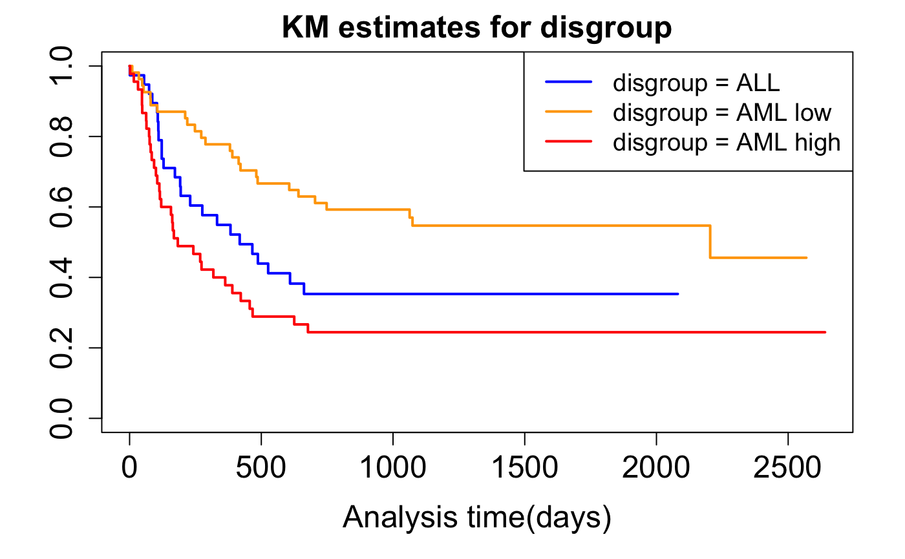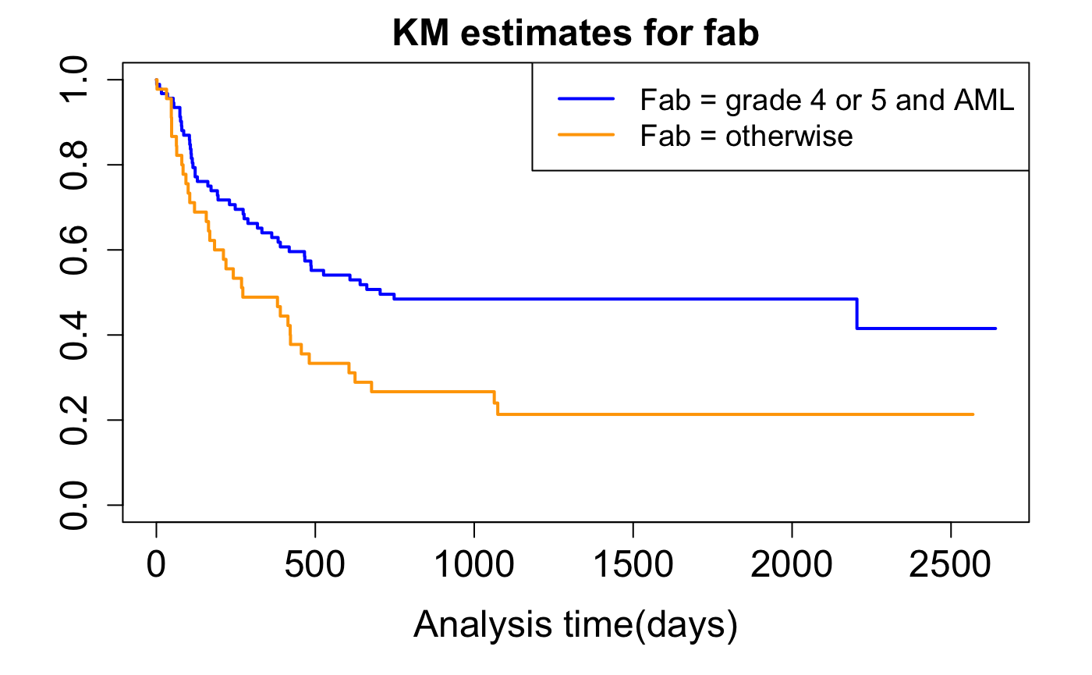

## Figure 2. Cox model estimated disease-free survival by disease group and by FAB classification

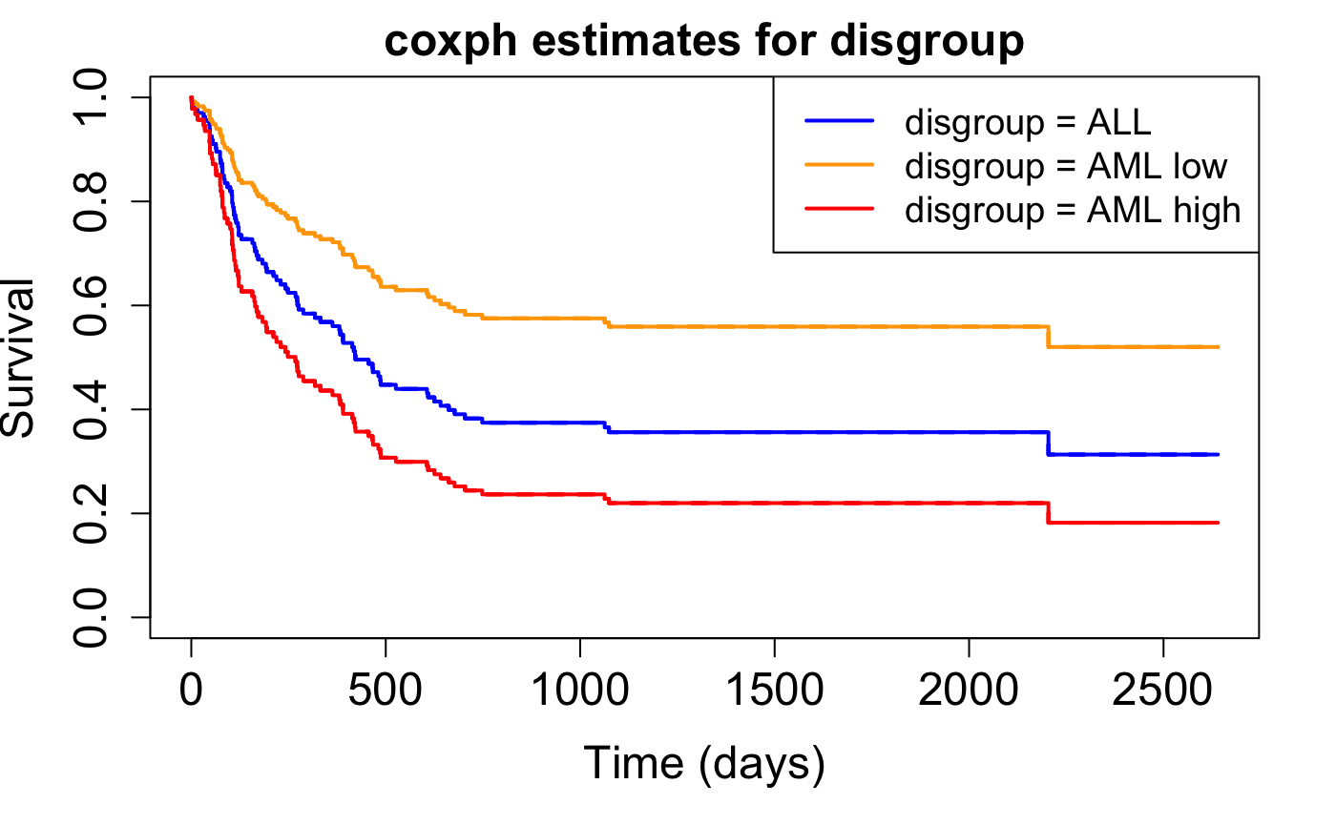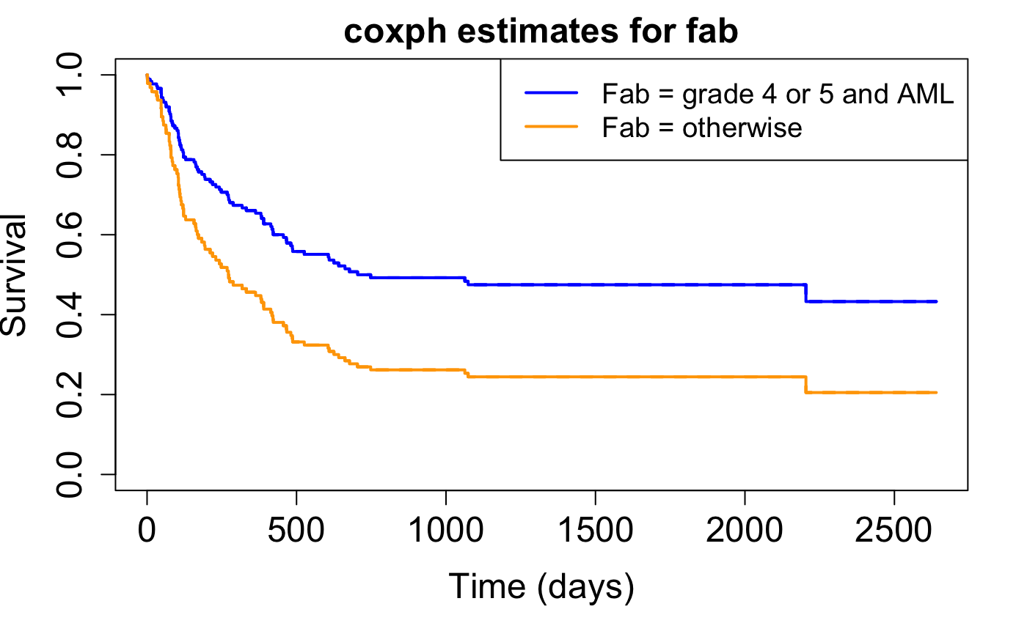

## Figure 3. Schoenfeld residuals of coefficients from disease-free survival prognosis model

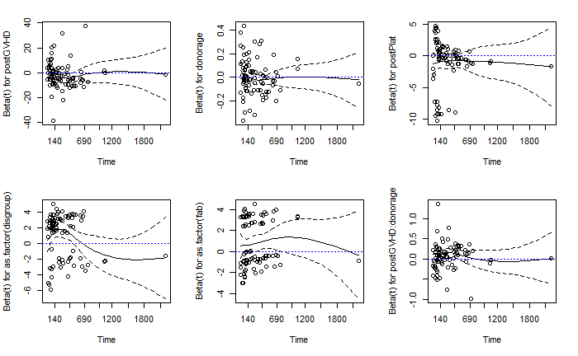

Note: in testing whether there is a significant trend in these plots through cox.zph function, there is no significant evidence that these variables deviate from PH.

## Figure 4. Comparison of parametric model fit for disease-free survival prognosis model

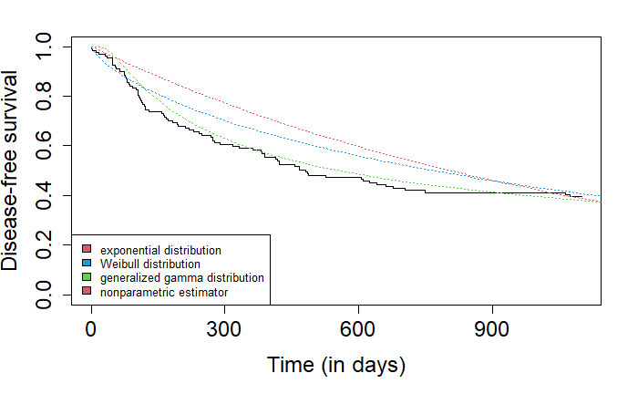

## Figure 5. Weibull AFT estimated disease-free survival by methotrexate adjusting for age and disease group

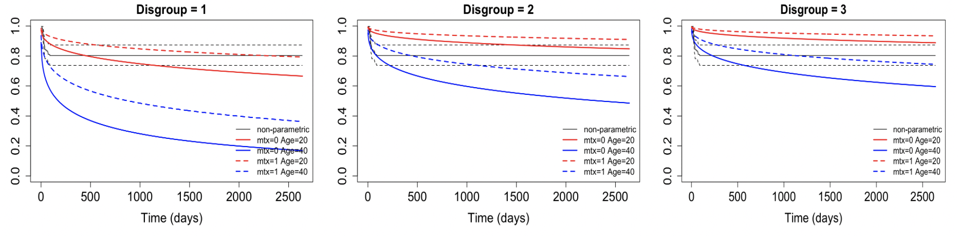

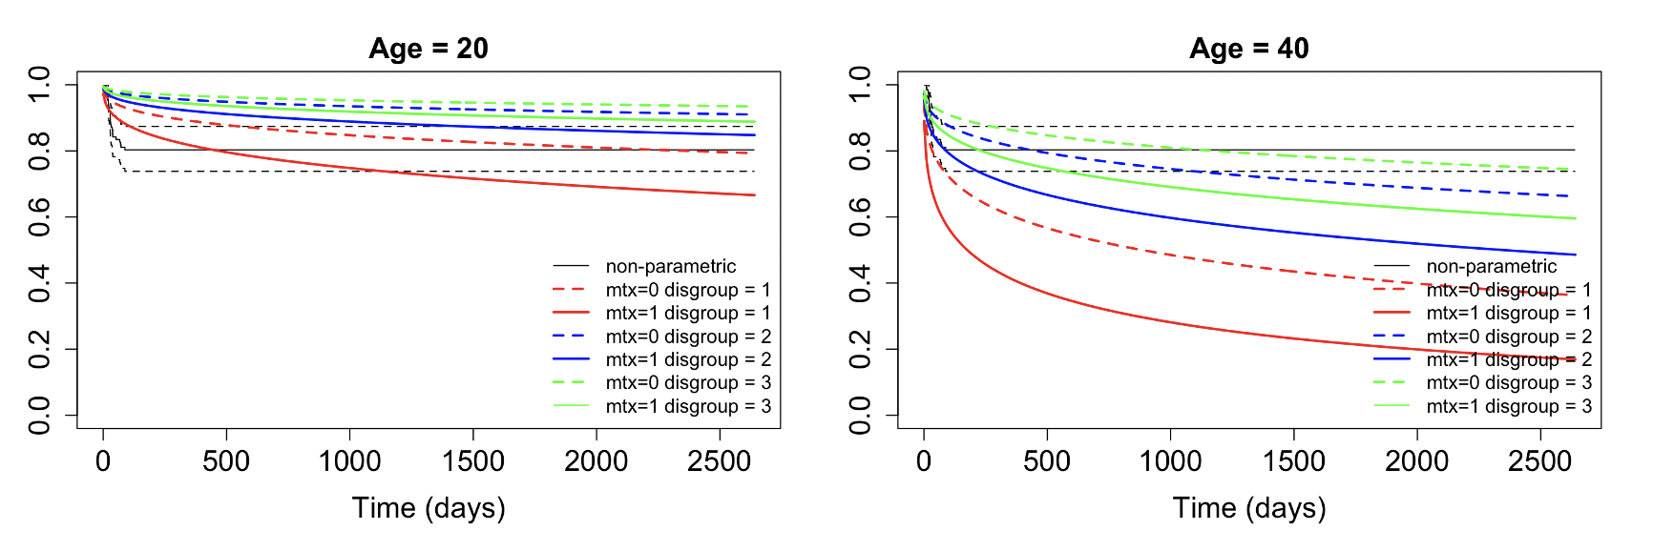

## 

# **Appendix. R codes**

## Table 1

library(tableone)

vars<-c("age", "donorage", "waittime", "male", "donormale", "cmv", "donorcmv", "fab", "mtx", "hospital", "ts", "tdfs", "deltadfs")

cat_vars<-c("male", "donormale", "cmv", "donorcmv", "fab", "mtx", "deltadfs", "hospital")

tab1<-CreateTableOne(vars=vars, strata="disgroup", data=bmt, factorVars=cat_vars)

print(tab1, showAllLevels=TRUE)

tab_overall<-CreateTableOne(vars=vars, data=bmt, factorVars=cat_vars)

print(tab_overall, showAllLevels=TRUE)

## Table 2

summary(coxph(Surv(tdfs,deltadfs)~age,data=bmt))

summary(coxph(Surv(tdfs,deltar)~age,data=bmt))

## patient gender

summary(coxph(Surv(tdfs,deltadfs)~male,data=bmt))

summary(coxph(Surv(tdfs,deltar)~male,data=bmt))

## donor age

summary(coxph(Surv(tdfs,deltadfs)~donorage,data=bmt))

summary(coxph(Surv(tdfs,deltar)~donorage,data=bmt))

## donor gender

summary(coxph(Surv(tdfs,deltadfs)~donormale,data=bmt))

summary(coxph(Surv(tdfs,deltar)~donormale,data=bmt))

## patient CMV

summary(coxph(Surv(tdfs,deltadfs)~cmv,data=bmt))

summary(coxph(Surv(tdfs,deltar)~cmv,data=bmt))

## donor CMV

summary(coxph(Surv(tdfs,deltadfs)~donorcmv,data=bmt))

summary(coxph(Surv(tdfs,deltar)~donorcmv,data=bmt))

## the wait time from diagnosis to transplantation

summary(coxph(Surv(tdfs,deltadfs)~waittime,data=bmt))

summary(coxph(Surv(tdfs,deltar)~waittime,data=bmt))

## disease group

summary(coxph(Surv(tdfs,deltadfs)~as.factor(disgroup),data=bmt))

summary(coxph(Surv(tdfs,deltar)~as.factor(disgroup),data=bmt))

## FAB classification

summary(coxph(Surv(tdfs,deltadfs)~fab,data=bmt))

summary(coxph(Surv(tdfs,deltar)~fab,data=bmt))

## prophylactic use of methotrexate

summary(coxph(Surv(tdfs,deltadfs)~mtx,data=bmt))

summary(coxph(Surv(tdfs,deltar)~mtx,data=bmt)

## hospital center

summary(coxph(Surv(tdfs,deltadfs)~as.factor(hospital),data=bmt))

summary(coxph(Surv(tdfs,deltar)~as.factor(hospital),data=bmt))

###aGVHD time-varying

bmt.tvc=tmerge(data1=bmt,data2=bmt,id=id,deltadfs=event(tdfs,deltadfs),postGVHD=tdc(ta))

head(bmt.tvc)

s.bmt.tvc<-Surv(bmt.tvc$tstart,bmt.tvc$tstop,bmt.tvc$deltadfs)

summary(coxph(s.bmt.tvc~postGVHD ,data=bmt.tvc))

bmt.tvc=tmerge(data1=bmt,data2=bmt,id=id,deltadfs=event(tdfs,deltar),postGVHD=tdc(ta))

head(bmt.tvc)

s.bmt.tvc<-Surv(bmt.tvc$tstart,bmt.tvc$tstop,bmt.tvc$deltar)

summary(coxph(s.bmt.tvc~postGVHD ,data=bmt.tvc))

### normal platelet levels

bmt.tvc=tmerge(data1=bmt,data2=bmt,id=id,deltadfs=event(tdfs,deltadfs),postplat=tdc(tp))

head(bmt.tvc)

s.bmt.tvc<-Surv(bmt.tvc$tstart,bmt.tvc$tstop,bmt.tvc$deltadfs)

summary(coxph(s.bmt.tvc~postplat,data=bmt.tvc))

bmt.tvc=tmerge(data1=bmt,data2=bmt,id=id,deltadfs=event(tdfs,deltar),postplat=tdc(tp))

head(bmt.tvc)

s.bmt.tvc<-Surv(bmt.tvc$tstart,bmt.tvc$tstop,bmt.tvc$deltar)

summary(coxph(s.bmt.tvc~postplat,data=bmt.tvc))

## Table 3

*# disease group + fab*

mod1<-coxph(Surv(tdfs,deltadfs)~as.factor(disgroup)+as.factor(fab),data=bmt)

Mod1

*# disease group + fab + patient cmv*

mod2<-coxph(Surv(tdfs,deltadfs)~cmv+as.factor(disgroup)+as.factor(fab),data=bmt)

mod2

anova(mod1,mod2)

*# disease group + fab + donor cmv*

mod3<-coxph(Surv(tdfs,deltadfs)~donorcmv+as.factor(disgroup)+as.factor(fab),data=bmt)

anova(mod1,mod3)

*# disease group + fab + aGVHD*

mod4<-coxph(Surv(tdfs,deltadfs)~deltaa+as.factor(disgroup)+as.factor(fab),data=bmt)

mod4

*# include aGVHD as time-varying covariate*

bmt.tvc=tmerge(data1=bmt,data2=bmt,id=id,deltadfs=event(tdfs,deltadfs),postGVHD=tdc(ta))

head(bmt.tvc)

s.bmt.tvc<-Surv(bmt.tvc$tstart,bmt.tvc$tstop,bmt.tvc$deltadfs)

mod5<-coxph(s.bmt.tvc~postGVHD+as.factor(disgroup)+as.factor(fab),data=bmt.tvc) *# p=0.313*

mod5

*# further include recovery of platelet as time-varying covariate*

bmt.tvc=tmerge(data1=bmt,data2=bmt,id=id,deltadfs=event(tdfs,deltadfs),postGVHD=tdc(ta),postPlat=tdc(tp))

head(bmt.tvc)

s.bmt.tvc<-Surv(bmt.tvc$tstart,bmt.tvc$tstop,bmt.tvc$deltadfs)

mod5<-coxph(s.bmt.tvc~postGVHD+postPlat+as.factor(disgroup)+as.factor(fab),data=bmt.tvc)

mod5

*# include interaction between donor age and aGVHD*

mod6<-coxph(s.bmt.tvc~postGVHD*donorage+postPlat+as.factor(disgroup)+as.factor(fab),data=bmt.tvc)

mod6

confint.default(mod6) %>% exp()

anova(mod5,mod6)

## Table 4

# baseline factors and differences in DFS

## patient age

coxph(Surv(tdfs,deltadfs)~age,data=bmt %>% filter(deltaa==1)) %>% confint() %>% exp()

## patient gender

coxph(Surv(tdfs,deltadfs)~male,data=bmt %>% filter(deltaa==1)) %>% confint() %>% exp()

## donor age

coxph(Surv(tdfs,deltadfs)~donorage,data=bmt %>% filter(deltaa==1)) %>% confint() %>% exp()

## donor gender

coxph(Surv(tdfs,deltadfs)~donormale,data=bmt %>% filter(deltaa==1)) %>% confint() %>% exp()

## patient CMV

coxph(Surv(tdfs,deltadfs)~cmv,data=bmt %>% filter(deltaa==1)) %>% confint() %>% exp()

## donor CMV

coxph(Surv(tdfs,deltadfs)~donorcmv,data=bmt %>% filter(deltaa==1)) %>% confint() %>% exp()

## the wait time from diagnosis to transplantation

coxph(Surv(tdfs,deltadfs)~waittime,data=bmt %>% filter(deltaa==1)) %>% confint() %>% exp()

## disease group

coxph(Surv(tdfs,deltadfs)~as.factor(disgroup),data=bmt %>% filter(deltaa==1)) %>% confint() %>% exp() # 0.5537, .0463

## FAB classification

coxph(Surv(tdfs,deltadfs)~fab,data=bmt %>% filter(deltaa==1)) %>% confint() %>% exp()

## prophylactic use of methotrexate

coxph(Surv(tdfs,deltadfs)~mtx,data=bmt %>% filter(deltaa==1)) %>% confint() %>% exp()

## Figure 1

### adjusting for age and disgroup

fit_mtx_exp<- flexsurvreg(Surv(ta, deltaa) ~ age + mtx + as.factor(disgroup), data = bmt, dist = "exponential")

fit_mtx_wb <- flexsurvreg(Surv(ta, deltaa) ~ age + mtx + as.factor(disgroup), data = bmt, dist = "weibull")

fit_mtx_gg<- flexsurvreg(Surv(ta, deltaa) ~ age + mtx + as.factor(disgroup), data = bmt, dist = "gengamma")

### warning : Optimisation has probably not converged to the maximum likelihood - Hessian is not positive definite. So I don't consider gengamma here

T_LRT <- -2*(fit_mtx_exp$loglik - fit_mtx_wb$loglik)

1- pchisq(T_LRT, df = 1)

###so weibull is better than exponential model

fit_mtx_wb

###Wald test for significance

wbres <- fit_mtx_wb$res

wbres.wald <- wbres[,1]/wbres[,4]

2*pnorm(-abs(wbres.wald))

##mtx not significant

summary(bmt$disgroup)

profile1 =data.frame(mtx = 0, age = 20, disgroup = as.factor(1))

profile2 =data.frame(mtx = 0, age = 40, disgroup = as.factor(1))

profile3 =data.frame(mtx = 1, age = 20, disgroup = as.factor(1))

profile4 =data.frame(mtx = 1, age = 40, disgroup = as.factor(1))

plot(fit_mtx_wb, newdata = profile1, col = "red", lwd = 2, lty = 1, xlab = "Time (days)",main = "Disgroup = 1", ci = FALSE, lwd.obs = 1, cex.lab=1.5, cex.axis=1.5, cex.main=1.5, cex.sub=1.5)

lines(fit_mtx_wb, newdata = profile2, col = "blue",lwd = 2, lty = 1, ci = FALSE)

lines(fit_mtx_wb, newdata = profile3, col = "red",lwd = 2, lty = 2, ci = FALSE)

lines(fit_mtx_wb, newdata = profile4, col = "blue",lwd = 2, lty = 2, ci = FALSE)

legend("bottomright", legend =c("non-parametric","mtx=0 Age=20", "mtx=0 Age=40", "mtx=1 Age=20", "mtx=1 Age=40"), col =c("black","red", "blue", "red", "blue"), lty =c(1,1, 1, 2, 2), lwd =c(1,2,2,2,2), cex = 1, bty = "n")

profile1 =data.frame(mtx = 0, age = 20, disgroup = as.factor(2))

profile2 =data.frame(mtx = 0, age = 40, disgroup = as.factor(2))

profile3 =data.frame(mtx = 1, age = 20, disgroup = as.factor(2))

profile4 =data.frame(mtx = 1, age = 40, disgroup = as.factor(2))

plot(fit_mtx_wb, newdata = profile1, col = "red", lwd = 2, lty = 1, xlab = "Time (days)", ci = FALSE, lwd.obs = 1, cex.lab=1.5, cex.axis=1.5, cex.main=1.5, cex.sub=1.5, main = "Disgroup = 2")

lines(fit_mtx_wb, newdata = profile2, col = "blue",lwd = 2, lty = 1, ci = FALSE)

lines(fit_mtx_wb, newdata = profile3, col = "red",lwd = 2, lty = 2, ci = FALSE)

lines(fit_mtx_wb, newdata = profile4, col = "blue",lwd = 2, lty = 2, ci = FALSE)

legend("bottomright", legend =c("non-parametric","mtx=0 Age=20", "mtx=0 Age=40", "mtx=1 Age=20", "mtx=1 Age=40"), col =c("black","red", "blue", "red", "blue"), lty =c(1,1, 1, 2, 2), lwd =c(1,2,2,2,2), cex = 1, bty = "n")

profile1 =data.frame(mtx = 0, age = 20, disgroup = as.factor(3))

profile2 =data.frame(mtx = 0, age = 40, disgroup = as.factor(3))

profile3 =data.frame(mtx = 1, age = 20, disgroup = as.factor(3))

profile4 =data.frame(mtx = 1, age = 40, disgroup = as.factor(3))

plot(fit_mtx_wb, newdata = profile1, col = "red", lwd = 2, lty = 1, xlab = "Time (days)", ci = FALSE, lwd.obs = 1, cex.lab=1.5, cex.axis=1.5, cex.main=1.5, cex.sub=1.5, main = "Disgroup = 3")

lines(fit_mtx_wb, newdata = profile2, col = "blue",lwd = 2, lty = 1, ci = FALSE)

lines(fit_mtx_wb, newdata = profile3, col = "red",lwd = 2, lty = 2, ci = FALSE)

lines(fit_mtx_wb, newdata = profile4, col = "blue",lwd = 2, lty = 2, ci = FALSE)

legend("bottomright", legend =c("non-parametric","mtx=0 Age=20", "mtx=0 Age=40", "mtx=1 Age=20", "mtx=1 Age=40"), col =c("black","red", "blue", "red", "blue"), lty =c(1,1, 1, 2, 2), lwd =c(1,2,2,2,2), cex = 1, bty = "n")

profile1 =data.frame(mtx = 0, age = 20, disgroup = as.factor(1))

profile2 =data.frame(mtx = 1, age = 20, disgroup = as.factor(1))

profile3 =data.frame(mtx = 0, age = 20, disgroup = as.factor(2))

profile4 =data.frame(mtx = 1, age = 20, disgroup = as.factor(2))

profile5 =data.frame(mtx = 0, age = 20, disgroup = as.factor(3))

profile6 =data.frame(mtx = 1, age = 20, disgroup = as.factor(3))

plot(fit_mtx_wb, newdata = profile1, col = "red", lwd = 2, lty = 1, xlab = "Time (days)", ci = FALSE, lwd.obs = 1, cex.lab=1.5, cex.axis=1.5, cex.main=1.5, cex.sub=1.5, main = "Age = 20")

lines(fit_mtx_wb, newdata = profile2, col = "red",lwd = 2, lty = 2, ci = FALSE)

lines(fit_mtx_wb, newdata = profile3, col = "blue",lwd = 2, lty = 1, ci = FALSE)

lines(fit_mtx_wb, newdata = profile4, col = "blue",lwd = 2, lty = 2, ci = FALSE)

lines(fit_mtx_wb, newdata = profile5, col = "green",lwd = 2, lty = 1, ci = FALSE)

lines(fit_mtx_wb, newdata = profile6, col = "green",lwd = 2, lty = 2, ci = FALSE)

legend("bottomright", legend =c("non-parametric","mtx=0 disgroup = 1", "mtx=1 disgroup = 1", "mtx=0 disgroup = 2","mtx=1 disgroup = 2", "mtx=0 disgroup = 3", "mtx=1 disgroup = 3" ), col =c("black","red","red","blue","blue", "green","green"), lty =c(1,2, 1, 2, 1, 2), lwd =c(1,2,2,2, 2, 2), cex = 1, bty = "n")

profile1 =data.frame(mtx = 0, age = 40, disgroup = as.factor(1))

profile2 =data.frame(mtx = 1, age = 40, disgroup = as.factor(1))

profile3 =data.frame(mtx = 0, age = 40, disgroup = as.factor(2))

profile4 =data.frame(mtx = 1, age = 40, disgroup = as.factor(2))

profile5 =data.frame(mtx = 0, age = 40, disgroup = as.factor(3))

profile6 =data.frame(mtx = 1, age = 40, disgroup = as.factor(3))

plot(fit_mtx_wb, newdata = profile1, col = "red", lwd = 2, lty = 1, xlab = "Time (days)", ci = FALSE, lwd.obs = 1, cex.lab=1.5, cex.axis=1.5, cex.main=1.5, cex.sub=1.5, main = "Age = 40")

lines(fit_mtx_wb, newdata = profile2, col = "red",lwd = 2, lty = 2, ci = FALSE)

lines(fit_mtx_wb, newdata = profile3, col = "blue",lwd = 2, lty = 1, ci = FALSE)

lines(fit_mtx_wb, newdata = profile4, col = "blue",lwd = 2, lty = 2, ci = FALSE)

lines(fit_mtx_wb, newdata = profile5, col = "green",lwd = 2, lty = 1, ci = FALSE)

lines(fit_mtx_wb, newdata = profile6, col = "green",lwd = 2, lty = 2, ci = FALSE)

legend("bottomright", legend =c("non-parametric","mtx=0 disgroup = 1", "mtx=1 disgroup = 1", "mtx=0 disgroup = 2","mtx=1 disgroup = 2", "mtx=0 disgroup = 3", "mtx=1 disgroup = 3" ), col =c("black","red","red","blue","blue", "green","green"), lty =c(1,2, 1, 2, 1, 2), lwd =c(1,2,2,2, 2, 2), cex = 1, bty = "n")

## Figure 2

###KM for disgroup

km.bmt.dg = survfit(Surv(tdfs, deltadfs) ~ as.factor(disgroup), data = bmt, conf.type = "log-log" )

plot(km.bmt.dg,col = c("blue", "orange", "red"), lwd = 2, xlab = "Analysis time(days)", main = "KM estimates for disgroup", cex.lab=1.5, cex.axis=1.5, cex.main=1.5, cex.sub=1.5)

legend("topright", c("disgroup = ALL", "disgroup = AML low", "disgroup = AML high"), col = c("blue", "orange", "red"), lwd = c(2,2), cex = 1.2)

###Coxph for disgroup

coxph.bmt.dg = coxph(Surv(tdfs,deltadfs) ~ as.factor(disgroup), data=bmt)

profile1 =data.frame(disgroup = as.factor(1))

profile2 =data.frame(disgroup = as.factor(2))

profile3 =data.frame(disgroup = as.factor(3))

plot(survfit(coxph.bmt.dg, newdata = profile1, conf.int = 0),col = "blue", lwd = 2, xlab = "Time (days)",ylab = "Survival",main = "coxph estimates for disgroup", cex.lab=1.5, cex.axis=1.5, cex.main=1.5, cex.sub=1.5)

lines(survfit(coxph.bmt.dg, newdata = profile2, conf.int = 0),col = "orange", lwd = 2)

lines(survfit(coxph.bmt.dg, newdata = profile3, conf.int = 0),col = "red", lwd = 2)

legend("topright", c("disgroup = ALL", "disgroup = AML low", "disgroup = AML high"), col = c("blue", "orange", "red"), lwd = c(2,2,2), cex = 1.2)

## Figure 3

###KM for fab

km.bmt.fab = survfit(Surv(tdfs, deltadfs) ~ fab, data = bmt, conf.type = "log-log")

plot(km.bmt.fab, col = c("blue", "orange"), lwd = 2, xlab = "Analysis time(days)", main = "KM estimates for fab", cex.lab=1.5, cex.axis=1.5, cex.main=1.5, cex.sub=1.5)

legend("topright", c("Fab = grade 4 or 5 and AML", "Fab = otherwise"), col = c("blue", "orange"), lwd = c(2,2), cex = 1.2)

###Coxph for fab

coxph.bmt.fab = coxph(Surv(tdfs,deltadfs) ~ fab, data=bmt)

profile1 =data.frame(fab = 0)

profile2 =data.frame(fab = 1)

plot(survfit(coxph.bmt.fab, newdata = profile1, conf.int = 0),col = "blue", lwd = 2, xlab = "Time (days)",ylab = "Survival",main = "coxph estimates for fab" ,cex.lab=1.5, cex.axis=1.5, cex.main=1.5, cex.sub=1.5)

lines(survfit(coxph.bmt.fab, newdata = profile2, conf.int = 0),col = "orange", lwd = 2)

legend("topright", c("Fab = grade 4 or 5 and AML", "Fab = otherwise"), col = c("blue", "orange"), lwd = c(2,2), cex = 1.2)

## Figure 4

*# test of PH assumptions*

zp<-cox.zph(mod6,transform=**function**(time)time)

zp

par(mfrow=c(2,3))

**for**(i **in** 1:6){

plot(zp[i])

abline(0,0,col="blue",lty=3)

}

## Figure 5

*# compare different model fits*

fitweibull<-flexsurvreg(Surv(tdfs,deltadfs)~deltaa*donorage+deltap+as.factor(disgroup)+as.factor(fab),data=bmt,dist="weibull")

fitggamma<-flexsurvreg(Surv(tdfs,deltadfs)~deltaa*donorage+deltap+as.factor(disgroup)+as.factor(fab),data=bmt,dist="gengamma")

fitexp<-flexsurvreg(Surv(tdfs,deltadfs)~deltaa*donorage+deltap+as.factor(disgroup)+as.factor(fab),data=bmt，dist="exp")

*# plotting*

plot(survfit(Surv(tdfs,deltadfs)~1, data=bmt), conf.int=FALSE,mark.time=FALSE,

xlim=c(0,1100), xaxt='n', cex.axis=1.5, cex.lab=1.5,

xlab="Time (in days)",ylab="Disease-free survival",lwd=1.5)

axis(1,at=seq(0,1100,by=300),labels=seq(0,1100,by=300),cex.axis=1.5)

lines(fitweibull,col=4,ci=FALSE,lwd=1.8,lty=3)

lines(fitggamma,col=3,ci=FALSE,lwd=1.8,lty=3)

lines(fitexp,col=2,ci=FALSE,lwd=1.8,lty=3)

legend("bottomleft",legend=c("exponential distribution","Weibull distribution",

"generalized gamma distribution",

"nonparametric estimator"),fill=c(2,4,3),cex=0.8)